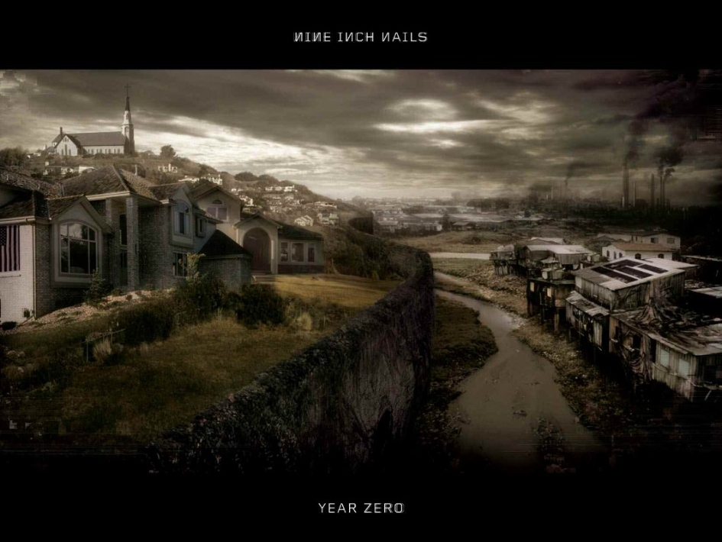

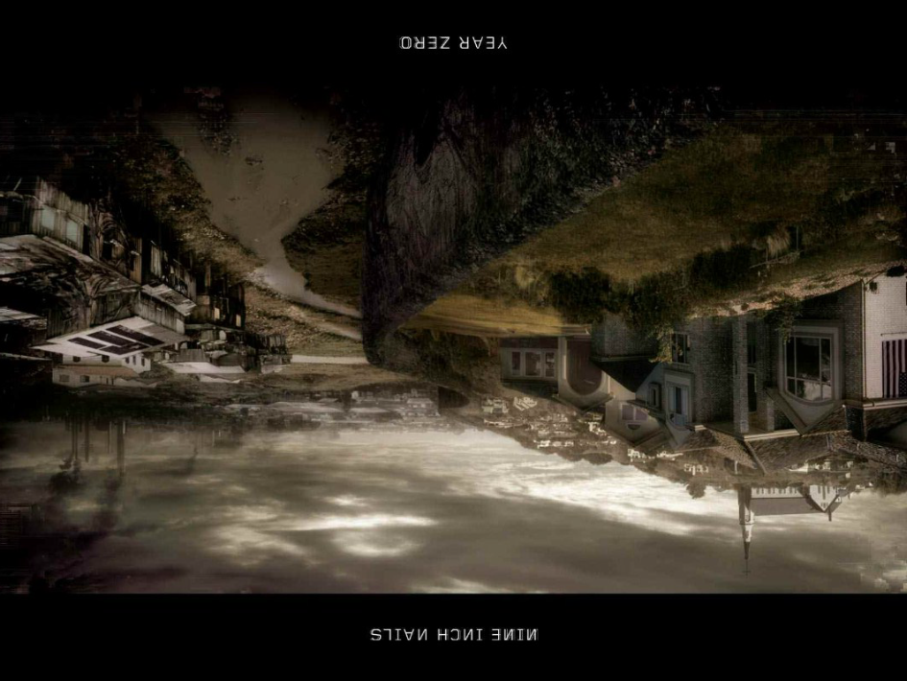

Index

Cover

Thesis

Songs

Let’s Roll—Neil Young (2001)

Holiday—Greenday (21 September 2004)

Boom!—System of a Down (November 26, 2002)

In a World Gone Mad—Beastie Boys (2004 )

Final Straw—REM (October 5, 2004 )

Prophets of War—Dream Theater (April 13th, 2007 )

The Good Soldier—Nine Inch Nails (Feb. 6, 2007 )

B.Y.O.B.—System of a Down (May 17, 2005 )

Megalomaniac—Incubus (5/4/2004 )

Capital G—Nine Inch Nails (Feb. 6, 2007 )

Songs not featured that still apply to thesis as additional proof:

A. Let’s impeach the President – Neil young ← May 9, 2006

B. Bu$hleaguer – Pearl Jam ← 10/12/2002

C. Life during wartime –pinhead gunpowder

The Cover’s Story: This artwork comes from a Nine Inch Nails album. I modified the picture so its mirror image (upside-down and backwards) was underneath the original photo. This is like America’s view of the world, upside-down and backwards.

Music’s Thoughts on Iraq

In the past few years, in the time following the surge up to the present, a long string of antiwar songs have been released. Most are still in the more subtle stage of lyrics but hint at some very important issues. The first powerful songs to be released were directly following the initial invasion of Iraq in a short little rock opera. Every major event following this was countered with a major song, which received at least some air time. Although the majority of Americans are not opposed to the war, at least not enough to take action, there is a growing dislike of the war and the President who started it. Time will progress and the war begins to affect more and more aspects of life. The only possible result of this escalation is that the public will take more notice to the war?
The songs of this generation cover many important issues, maybe even some that aren’t often thought of. There are some heavy points -- centered mostly on a general call to action to stand against injustice. This will be a recurring theme throughout the song selection. This war has come to be known as Bush’s war. As such, some of these works will be a shot across his bow.
Some background about this topic is needed before proceeding on to the music. The issues in the Middle East dates back to the cold war and the fight against communism. To help aid the fight against communism the United States made some rash decisions and propped up some bad people. In short, by supplying Saddam Hussein (and Bin Ladon) with weapons and training, he was able to keep his people under militant rule which, at the time the U.S.A. saw as a “positive” step away from communism.
A series of lies and minced words produced a legitimate argument for U.S. officials looking for a fight. Some of the most notable and recognizable of these are as follows: Iraq’s possession of Weapons of Mass Destruction (WMD); a cooperative coalition of al-Qaeda and Saddam. President Bush and other officials also made a false connection for the public between Iraq and 9/11 to draw in sympathy. At that time, the entire world was behind us. They believed we were in the right. That was soon to change.
The initial surge of troops was led by the United States, although there was a mix of nations who supplied troops. The coalition of troops came primarily from the U.K. and the U.S. (aka x-Tony Blair).
The perspective thoughts on the war and its actual cause can range and very from person to person. The government still claims that the war is over human rights violations, furthering the spread of democracy, and the support Iraq has been giving to Palestinian suicide bombers. The other side of the coin is the public’s opinion. The general view is becoming more and more centered on Iraq’s oil reserves, which the American way of life is centered around.
As the war escalates, more and more money will be spent (on top of what has already been used.) Traditionally, the economy thrives off of war. Now, coupled with supply-side economics, the war has damaged the economy. There is a fear of a recession and the government has been introducing a stimulus package to aid in the repair. The big question people are asking is, “What are we even fighting over?”
Hopefully someone knows the answer.

Song #1 Let’s Roll – by Neil Young
Before incorrectly linking Iraq and the attack on the World Trade Center, there was the initial rush of enthusiasm for a war among the public. There was a strong rush of nationalism, which the Bush administration used to gain support. In a way. we can look upon this in a good way. To know that America has the strength to react so quickly, with such force, makes it easy to sleep at night. Now, looking back with hindsight, musicians hope that they can harness that same power used to start this war in a positive step towards peace.
This first song came out shortly after 9/11 and voiced the strong feelings that Americans all over the continent were feeling. At this time, the entire world was behind us in a united cause. The strong feelings were coming not just inside, but outside as well.
During the attack on the World Trade Center, there was another plane on its way to another target. A few brave men rose to the occasion and took down the terrorist’s controlling the plane. At the time, they knew their fate was sealed, and all they could hope to do was their duty to their country. These men saved countless other lives. Let’s Roll is about this incident. One of those few men (a former quarterback from West Chester U. / NFL) said, “Let’s roll!” before they set out down the isle. This song shows the progression of attitudes as the war continues.
Lyrics:
I know I said I love you,
I know you know it's true,
I've got to put the phone down,
and do what we got to do.
One's standing in the iselway,
Two more at the door,
We've got to get inside there,
Before they kill some more.
Time is runnin' out,
Let's roll.
Time is runnin' out,
Let's roll.
No time for indecision,
We've got to make a move,
I hope that we’re forgiven,
For what we got to….
How this all got started,
I'll never understand,
I hope someone can fly this thing,
And get us back to land.
Time is runnin' out,
Let's roll.
Time is runnin' out,
Let's roll.
No one has the answer,
But one thing is true,
You've got to turn on evil,
When it's coming after you,
You've gotta face it down,
And when it tries to hide,
You've gotta go in after it,
And never be denied,
Time is runnin' out,
Let's roll.
Let's roll for freedom,
Let's roll for love,
We're going after Satan,
On the wings of a dove,
Let's roll for justice,
Let's roll for truth,
Let's not let our children,
Grow up fearful in their youth.
Time is runnin' out,
Let's roll.
Time is runnin' out,
Let's roll.
Time is runnin' out,
Let's roll.

Song #2 Holiday—by Greenday (September 21st 2004)
This song was released after the initial invasion. Proceeding in a chronological fashion we can tie most every song to an important event. The entire American Idiot album was the first to really say anything derogatory about the war. This came out just long enough after the shock of 9/11 not to cause a disturbance within the public. At the time of its release, the album was a chart topper and a significant part of pop culture.
Piece by piece, we can break this song apart and see where it criticizes the war. In the first stanza, the ones who died without a name could be the countless soldiers who died fighting, or it could be anyone of the numerous lives lost in the destruction of the World Trade Center which at the time was still thought of as an Iraqi effort.
The chorus is saying that there’s been a lot of lies the government has been feeding us that have no depth. It goes on about how this is the start of a key point in history, hence, “The dawning of our lives.” When people need a break they go on a holiday to help them forget what’s going on in the world. So they’re saying we’re hiding from this big point in our lives.
The company that lost the war could go multiple ways. It could either be used in the military sense, a military company of soldiers, or a literal sense. The literal sense would date back to the military-industrial complex. The company loosing the war would be the one who were supplying the weapons.
An often-used fraze is to be marching out of time. When they mention a drum pounding out of time they’re saying that America isn’t listening to the rest of the world. Or, they, being the band, could be saying they don’t care what everyone says, they’re not going to be part of the war.
In the next stanza, there is a reference to a bag being placed over a statue. In Iraq, Sadam had statues of himself, and there is one video of the statue being removed. This might be making a reference to that scene. They’re hiding Sadam behind the bag.
Now comes the best part of the song: “Sieg Heil to the president Gasman”. Basically the band is making a reference to Hitler and comparing him to George Bush. The literal meaning is hail victory to the president. It was an expression often used under the Nazi regime. “Pulverize the Eiffel Towers…” this is making a reference to the anger the U.S. placed towards the French who would not aid in the initial surge. There were many harsh feelings towards them (remember Freedom Fries?). “Kill all the fags that don’t agree,” is saying that Bush has a very conservative board, and they’re willing to punish anyone who doesn’t agree with their ways.
Lyrics:
Say, hey!
Hear the sound of the falling rain
Coming down like an Armageddon flame (Hey!)
The shame
The ones who died without a name
Hear the dogs howling out of key
To a hymn called "Faith and Misery" (Hey!)
And bleed, the company lost the war today
I beg to dream and differ from the hollow lies
This is the dawning of the rest of our lives
On holiday
Hear the drum pounding out of time
Another protester has crossed the line (Hey!)
To find, the money's on the other side
Can I get another Amen? (Amen!)
There's a flag wrapped around a score of men (Hey!)
A gag, a plastic bag on a monument
I beg to dream and differ from the hollow lies
This is the dawning of the rest of our lives
On holiday
(Hey!)
(Say, hey!)
(3,4)
"The representative from California has the floor"
Sieg Heil to the president Gasman
Bombs away is your punishment
Pulverize the Eiffel towers
Who criticize your government
Bang bang goes the broken glass and
Kill all the fags that don't agree
Trials by fire, setting fire
Is not a way that's meant for me
Just cause, just cause, because we're outlaws yeah!
I beg to dream and differ from the hollow lies
This is the dawning of the rest of our lives
I beg to dream and differ from the hollow lies
This is the dawning of the rest of our lives
This is our lives on holiday
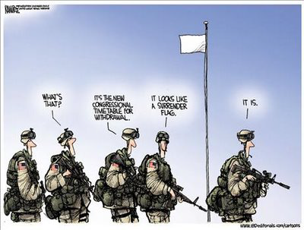

Song #3 Boom! – System of a Down

This song has a peace demonstration backing it. System of a Down (System), a strong political voice, has two of the songs selected for this project. When word of a possible invasion, or even a possible nuclear strike, reached the public’s ear there was a rapid amassment of people around the world to protest the war. In over 600 cities located around the world, citizens gathered together in a movement against the war. A total of ten million people were counted worldwide. This was the largest peace demonstration to ever happen in history. System of a Down participated in this demonstration. One of their videos says, “Because we choose peace over war, we were there too….”
The first stanza is basically setting up the scene. System is saying that the media has duped us, and that all of our emotions have fled from us. They’re saying that the media has caused us not to care about injustices anymore. The next stanza brings back a recurring theme: the military-industrial complex. System says that if the manufacturers approve a war it’s good to go, and it’s no longer in the hands of the government. No one cares any more; it’s just about the money. Now they take a shot at the listener’s hearts when they say how millions are spent on weapons while there are thousands of children starving. In the music video for this song one lady presents a very good point, “I just don’t see how killing children can help bring peace.”
A matador is a bullfighter who uses his cape to conceal a sword, which he uses to kill the bull. In this song, System presents the idea that companies are matadors. This comparison would make citizens the bulls, being killed by something that’s been concealed.

Lyrics:
I've been walking through your streets
Where all your moneys are earned
Where all your buildings crying
And clueless neckties working
Revolving fake-lawn houses
Housing all your fears
Desensitized by TV
Overbearing advertising
God of consumerism
And all your crooked pictures looking good
Mirrorism, filtering information for the public eye
Designed for profiteering
Your neighbor, what a guy.
BOOM! (4X)
Every time you drop the bomb, you kill the god your child has born-
BOOM! (4X)
Modern globalization
Coupled with condemnations
Unnecessary death
Matador corporations
Puppeting your frustrations with a blinded flag
Manufacturing consent is the name of the game
The bottom line is money
Nobody gives a FUCK
Four thousand hungry children leave us per hour from starvation
While billions are spent on bombs
Creating death showers
BOOM! (4X)
Every time you drop the bomb, you kill the god your child has born-
BOOM! (4X)
Boom-Boom-Boom-Boom-Boom-Boom-Boom!
Why must we kill our own kind?
BOOM! (4X)
Every time you drop the bomb, you kill the god your child has born.
BOOM! (4X)
Boom-Boom-Boom-Boom-Boom-Boom-Boom-Boom!
Every time you drop the bomb.

Song #4 In a World Gone Mad—Beastie Boys

This is a really unique song. The way that the Beastie Boys ruthlessly attack certain people and ideas makes this song truly effective and powerful. In the first stanza, which is also the chorus, they make a very powerful point about how there are people dieing constantly from murder. Murder is a negative term, and applying it to a warlike scenario gives a bad connotation.
In the second stanza the Boys address that the issue is how politicians are living to the public. By this point in the war news leaks were beginning to appear that the original intentions for the war were a farce. Halfway through the stanza they take a shot at Bush, saying that he’s only doing these things because he’s having his midlife crisis. The Boys say that the politicians have to be on drugs, and that the proof is in their actions.
Then they say that we went from a War on Terror to a War on Iraq. This has gone from a war fighting for democracy to a war fighting against a race of people. The Beastie Boys then continue to talk about how no one in America cares because the war isn’t getting anyone on the American home front killed. They make it a point to mention that they don’t like Bush, but that doesn’t mean they support Sadam. Yes, he’s a bad man, but that’s not really why we’re in there. Zoolander was an idiot male model. The reference connecting Bush to him is saying that Bush just wants to be in front of the camera even tough he’s an idiot.
Then, in that same stanza they proceed to address the economic strain the war is putting on the Nation. They also address the fact that the politicians are choosing to fight over continuing healthcare, something many of the elderly were counting on.
Lyrics:
[CHORUS]
In a world gone mad it's hard to think right
So much violence hate and spite
Murder going on all day and night
Due time we fight the non-violent fight
Mirrors, smokescreens and lies
It's not the politicians but their actions I despise
You and Saddam should kick it like back in the day
With the cocaine and Courvoisier
But you build more bombs as you get more bold
As your mid-life crisis war unfolds
All you want to do is take control
Now put that axis of evil bullshit on hold
Citizen rule number 2080
Politicians are shady
So people watch your back 'cause I think they smoke crack
I don't doubt it look at how they act
[CHORUS]
In a world gone mad it's hard to think right
So much violence hate and spite
Murder going on all day and night
Due time we fight the non-violent fight
First the 'War On Terror' now war on Iraq
We're reaching a point where we can't turn back
Let's lose the guns and let's lose the bombs
And stop the corporate contributions that their built upon
Well I'll be sleeping on your speeches 'til I start to snore
'Cause I won't carry guns for an oil war
As-Salamu alaikum, wa alaikum assalam
Peace to the Middle East peace to Islam
Now don't get us wrong 'cause we love America
But that's no reason to get hysterica
They're layin' on the syrup thick
We ain't waffles we ain't havin' it
[CHORUS]
In a world gone mad it's hard to think right
So much violence hate and spite
Murder going on all day and night
Due time we fight the non-violent fight
Now how many people must get killed?
For oil families pockets to get filled?
How many oil families get killed?
Not a damn one so what's the deal?
It's time to lead the way and de-escalate
Lose the weapons of mass destruction and the hate
Say ooh ah what's the White House doin'?
Oh no! Say, what in tarnation have they got brewing?!
Well I'm not pro Bush and I'm not pro Saddam
We need these fools to remain calm
George Bush you're looking like Zoolander
Trying to play tough for the camera
What am I on crazy pills? We've got to stop it
Get your hand out my grandma's pocket
We need health care more than going to war
You think it's democracy they're fighting for?
[CHORUS]
In a world gone mad it's hard to think right
So much violence hate and spite
Murder going on all day and night
Due time we fight the non-violent fight
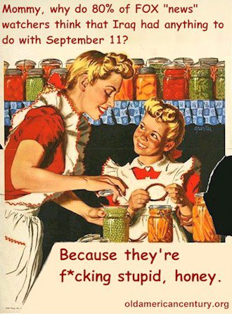

Song #5 Final Straw—REM
This is one of the best lyrical songs about the entire war. In the first stanza it starts out with a little side note about the Patriot act. The law that silenced REM was the US PATRIOT (Uniting and Strengthening America by Providing Appropriate Tools Required to Intercept and Obstruct Terrorism) act. Originally intended to help citizens feel more secure at home, this act was signed off by Congress and approved by President Bush on October 26, 2001. This act effectively granted powers to law enforcement, which under close scrutiny may go against the Constitution. There is a definite line that could be crossed under the jurisdiction of this law that would be a Constitutional violation.
In stanza three, REM goes on to say there’s a voice inside their head telling them that Bush will not win this war. REM tries to ignore this voice but no matter what the moral conscience continues to nag. Then they say something very important, “…Two wrongs make a right.” Even if Iraq did something wrong to us abusing them will do us no good, and will only irritate the matter. At this point in the matter the only thing that can save them is forgiveness. The next song, Prophets of War, addresses this same issue with similar words. This will become another recurring theme.

Lyrics:
As I raise my head to broadcast my objection
As your latest triumph draws the final straw
Who died and lifted you up to perfection?
And what silenced me is written into law.
I can't believe where circumstance has thrown me
And I turn my head away
If I look I'm not sure that I could face you.
Not again. not today. not today.
If hatred makes a play on me tomorrow
And forgiveness takes a back seat to revenge
There's a hurt down deep that has not been corrected.
There's a voice in me that says you will not win.
And if I ignore the voice inside,
Raise a half glass to my home.
But it's there that I am most afraid,
And forgetting doesn't hold. it doesn't hold.
Now I don't believe and I never did
That two wrongs make a right.
If the world were filled with the likes of you
Then I'm putting up a fight. I'm putting up a fight.
Putting up a fight. make it right. make it right.
Now love cannot be called into question.
Forgiveness is the only hope I hold.
And love- love will be my strongest weapon.
I do believe that I am not alone.
For this fear will not destroy me.
And the tears that have been shed
It's knowing now where I am weakest
And the voice in my head. in my head.
Then I raise my voice up higher
And I look you in the eye
And I offer love with one condition.
With conviction, tell me why.
Tell me why.
Tell me why.
Look me in the eye.
Tell me why.

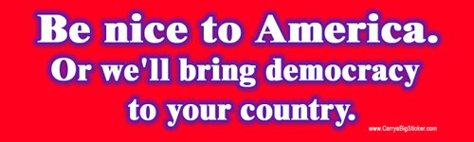

Song #6 Prophets of War—Dream Theater
Dream Theater is a little known band that ventures on the genera of Metal. For being such a hardcore music group they tackle some major issues with their use of lyrics combined with wicked guitar. This is one of their newer songs from the album, Systematic Chaos. The entire album plays like a rock opera. Several of the songs could be interpreted as antiwar, but this is the most blatantly open about it.
Let’s begin with the first stanza. Dream Theater (DT) starts off talking about an angry feeling at the America, ‘ourselves’. No one’s supposed to question the war, it’s just supposed to be a just cause. If we debate what’s going on the actual facts do no support what the government is saying. To liberate the Iraqi’s from Sadam is the only reason they tell us, but that’s not what it’s about.
Then DT goes on, we’ve been deceived and the brave people who are fighting don’t even know the reason. Now that we’ve gotten into this we’re compelled to finish what we’ve started but can we fix what we’ve done? Previously mentioned, DT thinks the only thing that will get us out of this war is faith that they will forgive us. Else we, by some miracle, end this war only to have it brought back to life should Iraq seek vengeance.
DT continues, don’t like the way things are, get used to it because they’re going to get worse, and they’ll hit you even closer to home. If you show any sympathy it will only be because the issue is affecting you now, and the little compassion you’re showing is pitiful. Then the say something that will hopefully make people take charge, “Responsible: of that you are incapable.” They’re saying, think this isn’t your problem too? If you do then you had better reconsider.
Debatably the most important part of the song is the chorus. It is more of a call to action than anything else. “Is it time to make a change?” After all the things that DT has said isn’t it time to fix this? Are we closer, or is this an ongoing fight? Can we help them or is this a lost cause? Are we profiting from the horrors of war? Now there was previously mentioned that money was actually being lost in this war. But, where is that money going? It’s going to the corporations who supply this war. Once more, the Military-Industrial complex takes charge.
Lyrics:
It burns deep down inside of me
We have ourselves to blame
Not questioning, accepted as the truth
Debate this fight its just cause
The facts do not supports theirs
To liberate a people
And rid them of tyrant rule
Is it time to make a change
Are we closer than before
Can we help them break away
Are we profiting from war
It's time to make a change
Intrigued
Got your attention - Deceived
Since the inception - Our brave
Fight for what reason
Compelled
Can we clean up this mess
The loss of loved ones
A perverse request
They continue the same rhetoric
These derelicts that profit
Win or lose
Is it time to make a change
Are we closer than before
Can we help them break away
Are we profiting from war
It's time to make a change
Time for change
Fight the fear
Find the truth
Time for change
The only thing
That I believe
Will help us see this through is faith
Pray they will forgive
Forgive our arrogance
So we can make it right
Right what they have wronged
See you sweat
Unexpected, controversial
Get used to it
Things are gonna get personal
Your sympathy
A pitiful display you stutter
Your empathy
Means nothing if there is no honor
Responsible
Of this you are incapable
We implicate
Incriminate - Exacerbate - Too much at stake
Our Fathers, Mothers
Sisters, Brothers
Sons and Daughters
Forced
Perpetuating their ideals
A mindless act
To stay the course
Is it time to make a change
Are we closer than before
Can we help them break away
Are we profiting from war
Is it time to make a change
Are we closer than before
Can we help them break away
Are we profiting from war
Is it time to make a change
A change from what it's been
Can we help them break away
Is our patience wearing thin
It's time to make a change
Time for change
Fight the fear
Find the truth
Time for change

Song # 7 The Good Soldier—Nine Inch Nails
Nine Inch Nails (NIN) is really a one-man band operated by Trent Reznor who, plays every instrument on the recordings. This song has many interpretations, one of which pertains to the Iraq war.
This could possibly be taking place in Iraq itself, or even here in America. The second line leads some to believe that the battle in question is happening here. This is supposed to be told from a first person perspective, so the man is stepping over the bodies that are littering the street. He can’t feel anymore. A good soldier would not be able to feel, feelings or pain, because that could be perceived as weakness. He is trying to see and believe what he is doing, but it just doesn’t make sense because he should not be fighting.
The part about blood hardening in sand leads others to believe the fight is happening in Iraq based on the terrain. The cold metal in the soldier’s hand would be the gun he uses. He hopes that his enemies understand there’s nothing left they can do now, with all the new weapons, and this good soldier, there is nowhere in the world they can hide. People often consider the war in Iraq to be a religious war, which would explain the, “God is on our side.”
The entire album, Year Zero, is supposed to take place in the year 2022, which is in the not-so-distant future. The cover to this project is an image from the coversheet. NIN is saying that we, as Americans, think we can get to this place where we’re so much better than everyone. Just listen…
Lyrics:
Gunfire in the street
Where we used to meet
Echoes that are beat
When the bass goes "bomb"
Right over my head
Step over the dead
Remember what you said
You know a part about life
Is just a waking dream
Well I know what you mean
But that ain't how it seems right here, right now
How can this be real?
I can barely feel
Anymore
I am trying to see
I am trying to believe
This is not where I should be
I am trying to believe
Blood hardens in the sand
Cold metal in my hand
Hope you understand the way that things are gonna be
There's nowhere left to hide
'Cause God is on our side
I keep telling myself
I am trying to see
I am trying to believe
This is not where I should be
I am trying to believe
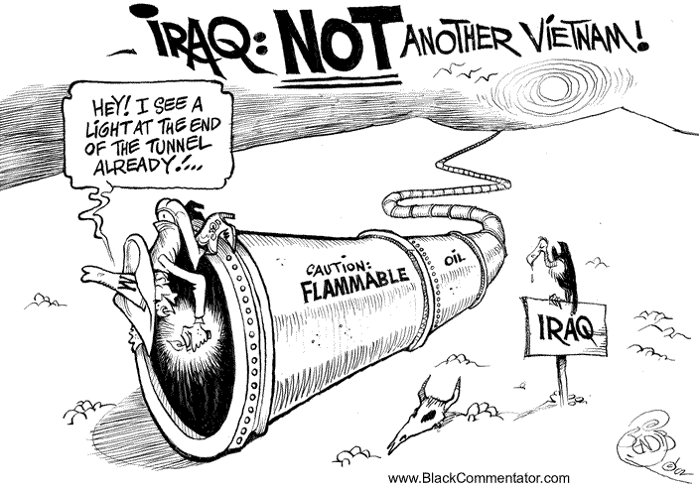
Song # 8 B.Y.O.B. – System of a Down

Here we have another appearance from the famous System of a Down. This song, B.Y.O.B. is more popular than the previous one, Boom!. B.Y.O.B. an acronym for bring your own bombs, has received substantial support from the public, and other beneficiaries. It is a song of fewer words but still; it yields no less of an effect. Systems passion really went into the song and, you can really feel the emotion coming from their words.
In a war the only people who traditionally fight are the lower to lower-middle classes. System poses a very good question: why? If presidents want to get us into wars why don’t they themselves get out there and do it themselves. New deals were made, Military-Industrial complex, to get this war going. The people getting us into these wars need protection from the lower classes yet, they feed them lies, scraps from the tablecloth.
There’s hangers sitting, soiled by the oil that this war is over. Those same hangers are crying freedom, what this war is supposed to be about. Why are they connected, they shouldn’t be.
Lyrics:
WHY DO THEY ALWAYS SEND THE POOR!
Barbarisms by Barbaras
With pointed heels.
Victorious, victories kneel.
For brand new spankin' deals.
Marching forward hypocritic
And hypnotic computers.
You depend on our protection,
Yet you feed us lies from the table cloth.
La la la la la la la la la,
Everybody’s going to the party have a real good time.
Dancing in the desert blowing up the sunshine.
Kneeling roses disappearing,
Into Moses’ dry mouth,
Breaking into Fort Knox,
Stealing our intentions,
Hangars sitting dripped in oil,
Crying FREEDOM!
Handed to obsoletion,
Still you feed us lies from the table cloth.
La la la la la la la la la,
Everybody’s going to the party have a real good time.
Dancing in the desert blowing up the sunshine.
Everybody’s going to the party have a real good time.
Dancing in the desert blowing up the sunshine.
Blast off, it's party time,
And we don't live in a fascist nation,
Blast off, it's party time,
And where the fuck are you?
Where the fuck are you?
Where the fuck are you?
Why don’t presidents fight the war?
Why do they always send the poor?
Why don’t presidents fight the war?
Why do they always send the poor? [X4]
Kneeling roses disappearing,
Into Moses’ dry mouth,
Breaking into Fort Knox,
Stealing our intentions,
Hangars sitting dripped in oil,
Crying FREEDOM!
Handed to obsoletion,
Still you feed us lies from the tablecloth.
La la la la la la la la la,
Everybody’s going to the party have a real good time.
Dancing in the desert blowing up the sunshine.
Everybody’s going to the party have a real good time.
Dancing in the desert blowing up the sunshine
Where the fuck are you!
Where the fuck are you!
Why don’t presidents fight the war?
Why do they always send the poor?
Why don’t presidents fight the war?
Why do they always send the poor? [X3]
Why, do, they always send the poor [X3]
They only send the poor [x2]

Song #9 Megalomaniac—Incubus
Ok, this was a new song for me but it’s currently one of my favorite songs. Incubus really knew what they were doing when they wrote this one. They start off describing propaganda and how this person, probably president Bush, is everywhere in the media even though they don’t want him to be. That if based off of right and wrong they would bring him down from his high place if they could. A megalomaniac is someone who has delusional dreams about wealth, power, and omnipotence. It is a psychopathical condition and Incubus is basically saying that Bush is a megalomaniac.
The message is that Bush thinks he was meant to be the only one in power, and that it he thinks he’s the bee’s knees. They’re saying that they wish they could make him see the wrongs he is doing to the world, specifically Iraq. Then they say he needs to step down because he is incompetent. Great song but it is another one with few words.
Lyrics:
I hear you on the radio
You permeate my screen, its' unkind but
If I met you in a scissor fight
I'd cut off both your wings on principle alone
On principle alone
Hey megalomaniac
You're no Jesus
Yeah, you're no fucking Elvis
Wash your hands clean of yourself baby
Maniac, step down, step down
If I were your appendages
I'd hold open your eyes
So you would see
That all of us are heaven sent
There was never meant to be only one
To be only one
Hey megalomaniac
You're no Jesus
Yeah, you're no fucking Elvis
Wash your hands clean of yourself baby
Maniac, step down, step down
Yeah
You're no Jesus
You're no Elvis
You're no Jesus
You're no Jesus
You're no Elvis
You're no answer
Step down, step down,
Step down, step down
Hey megalomaniac
You're no Jesus
Yeah, you're no fucking Elvis
Wash your hands clean of yourself baby
Maniac, step down, step,
Step down, step down,
Step down, step down,
Step down

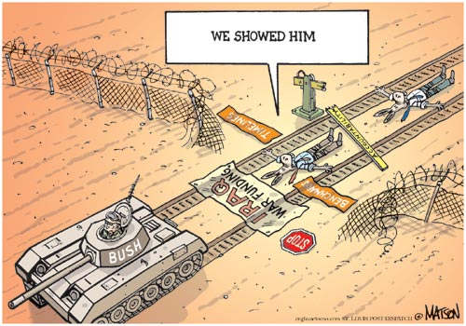

Song #10 Capital G—Nine Inch Nails

This great band has a lot to say about the world. This time they tackle a common thought people seem to have. People are coming to see this war as the president’s fight. In the past few songs feelings have gone from reasons against fighting in the war to criticizing George Bush. This war is becoming known as ‘Bush’s War’. That’s why I chose this to be the last song in this collection. Whether this is war is his fault or not I don’t know, and probably never will. I do know this war is not his responsibility; it is the citizens of the U.S.A. who sit around and let these injustices occur. For a nation who controls their government we sure have gone a far way from our original purpose. In the words of Pinhead Gunpowder, whose song is listed in the ‘Songs not featured that still apply to thesis as additional proof’ part of the index, “Revolution begins at home
but for most of us it ends there, too.”
Capital G is a political allegory in that NIN is comparing Bush to someone who thinks they’re God. God and George both begin with the letter ‘G’ so signing his name with a capital G would mean that George believes he is on the same level as God.
In the first stanza he starts off saying that Bush was elected at the push of a button so that Bush could push a button to kill people. Trent is sick of all these people complaining about the war, people need to be held accountable for their actions. Then he goes into a first person view of George. That he doesn’t care about global warming, that he doesn’t care about anyone to follow him, that he’s power hungry, and ignorant.
The chorus is coming from a citizen’s perspective. That he’s not supposed to believe in his religion anymore, that it’s all about worshiping the government and this man who signs his name with a capital G. Anyway, on with the lyrics:
Lyrics:
I pushed the button and elected elected him to office and a
He pushed the button and he dropped the bomb
You pushed the button and could watch it on the television
Those motherfuckers didn't last too long
I'm sick of hearing about the "have's" and "have not's"
Have some personal accountability
The biggest problem with the way that we've been doing things is
The more we let you have the less that I'll be keeping for me
Well I used to stand for something
Now I'm on my hands and knees
Trading in my god for this one
And he signs his name with a capital G
Don't give a shit about the temperature in Guatemala
Don't really see what all the fuss is about
Ain't gonna worry about no future generations and a
And I'm sure somebody's gonna figure it out
Don't try to tell me that some power can corrupt a person
You haven't had enough to know what its like
You're only angry 'cause you wish you were in my position
Now nod your head because you know that I'm right... alright!
Well I used to stand for something
But forgot what that could be
There's a lot of me inside you
Maybe you're afraid to see
Well I used to stand for something
Now I'm on my hands and knees
Trading in my god for this one
And he signs his name with a capital G

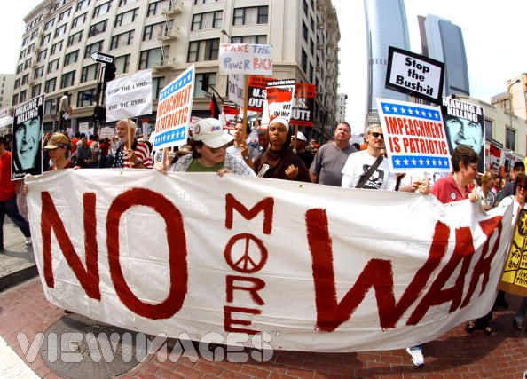

Works Cited

- http://lyricfreaks.com/
This is the only source I used for the project. The analysis and thesis were my own creation. The political cartoons cite their origin in the corner of the photo.

Work Log:

May—
27th Tuesday: Preliminary Research (30 minutes)
I spent this time researching songs that were opposed to a war in Iraq. I found that I already had a few, and that there were some I didn’t even think of. I was introduced to new music I had never herd as well.

June—
Wednesday 4th: 30 minutes

I spent this time finding the release dates of the songs so that I could like the songs to a specific event. This proved challenging as some songs showed no release date.
Thursday 5th: 45 minutes

I spent this time beginning my thesis.

Friday 6th: 45 minutes

I spent this time continuing my thesis.

Monday 9th: 45 minutes

More class time devoted to finishing my thesis,

Tuesday 10th: 45 minutes

I began to analyze the first song.

Wednesday 11th: 5 hours

I spent the class finishing up the first song, and starting another. At home I continued my work until finished the remainder of the songs followed by a brief editing period where my father read my report.

Thursday 12th: 1 hour 30 minutes

I spent class printing out my project and quotes for the cover. After class I went to staples and spent $1.00 on two cover sheets. Then I spent a few minutes assembling the project. I also spent $5.00 on a binder to keep it in. Later I spent time assembling a research log.

